PRESENTATION SHEET OF THE HISTORICAL NOVEL

**Costantino Brumidi**

Title: Costantino Brumidi, The Michelangelo of the United States. – The journey of a great painter from the Rome of the Popes to the Washington of Lincoln

Original title: **Costantino Brumidi**, Il Michelangelo degli Stati Uniti. – Viaggio di uno straordinario pittore dalla Roma papalina alla Washington di Lincoln

Author: Guglielmo Mariani

Publisher: Brè Edizioni

Pages 176 in 16x24 cm format

In ebook only on Amazon at €4.99, in softcover on Amazon at €27, in hardcover only on Amazon at €35, in softcover in bookshops or ISB La Feltrinelli and others online, at €22

Genre: historical illustrated novel in the form of a biography.

Link to Amazon <https://amzn.to/3qWvlay>

Release: 29 August 2021

**Synopsis**

Christmas 1850 is only a few days away; the government of the papal restoration is cancelling all the reforms produced by the Roman Republic and has instituted hundreds and hundreds of trials to punish those who participated in the epic revolt. In one of these mock-trials, the defendant was a great Roman painter, one of the best known and most appreciated artists of the time: Costantino Brumidi. Before the end of the year, Brumidi was condemned to eighteen years' imprisonment on the charge of 'Violent theft against the Venerable Monastery of St Francesca Romana'. After ten months in prison, Brumidi was pardoned by Pope Pius IX, but the pardon was followed by the exile, and he had to abandon his family and his possessions and emigrate to America. There he had the opportunity to fresco churches (New York, Washington, Baltimore, Philadelphia, Mexico City) and to do works for private patrons However, his most appreciated and imperishable work is the series of frescoes at the Capitol (thousands and thousands of square metres of themed frescoes), among which the 'Apotheosis of George Washington' and the 'President's Room' stand out, admired to date by more than 100 million visitors. During the 25 years he spent in Washington, Brumidi had the opportunity to meet important politicians, such as Lincoln, Jefferson Davis and Buchanan, but he also suffered fierce attacks from American artists envious of his great art. Today, the Capitol is considered a wonderful museum with a unique feature in the world, that of containing works by only one author: Constantine Brumidi. His life in America was a sort of revenge for what he had suffered in Rome. However, his art and his achievements are still unknown in his homeland. With this work, I want to pay homage to this great Italian artist.

**Biography**

Guglielmo Mariani, was Full Professor of Medicine at the Universities of Rome, Palermo and L'Aquila; he is the author of numerous publications, most of them in prestigious international scientific journals. From 2015 to 2021 he taught at the University of Westminster (London). For more than 20 years, he had been Co-ordinator/Principal Investigator of EU-funded projects focused on restructuring and modernization programs of Higher Education Institutions (Universities, Internships, Doctoral Programs) in Eastern European countries (Bulgaria, Georgia, Armenia, Azerbaijan). Since 2012 he has devoted himself to writing and, to date, has published six novels, Roberto L (Armando Curcio Editore, 2014), Il Gaullista di Parma (Editrice GDS, 2015), Traditi e Traditori (Il giovane Holden Editore, 2017), Tre pallottole, un revolver (Bré Edizioni, 2021) Costantino Brumidi (Bré Edizioni, 2021) and two popular science books: Il Manuale del Jogger (Bré Edizioni, 2022) and Il Nostro Sangue, co-authored by Pier Mannuccio Mannucci (Aracne, 2020). For more details see the site: www.guglielmomariani.com

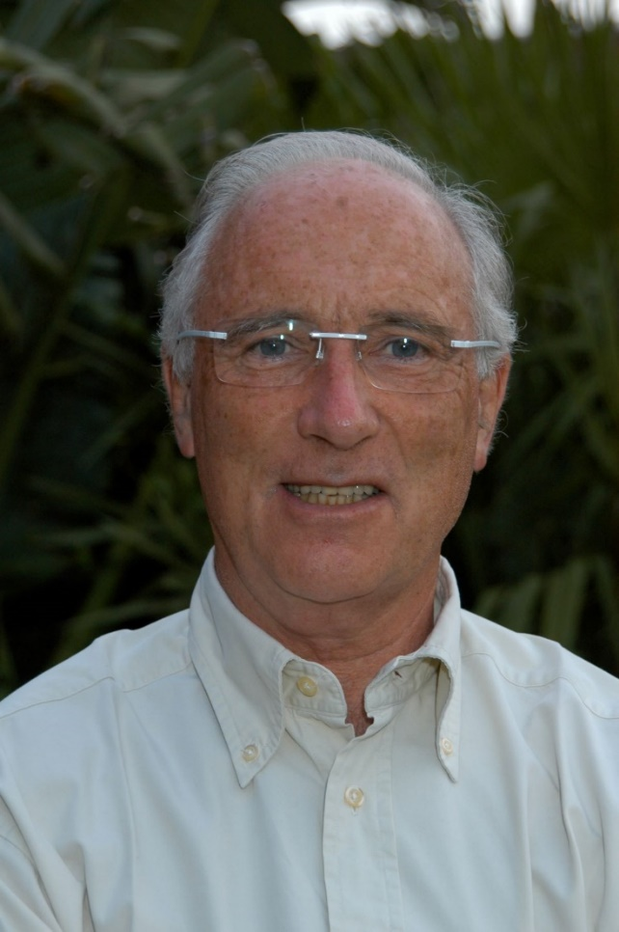

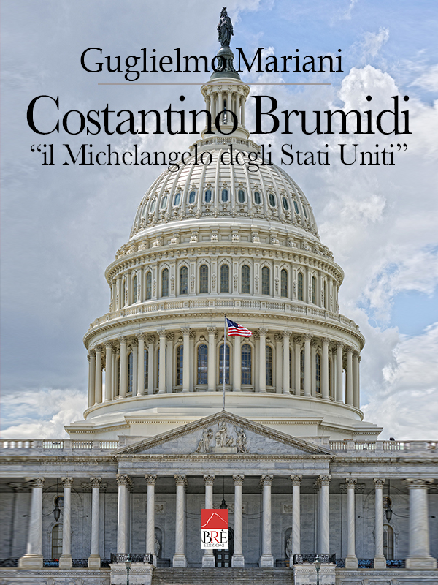

**Extract**

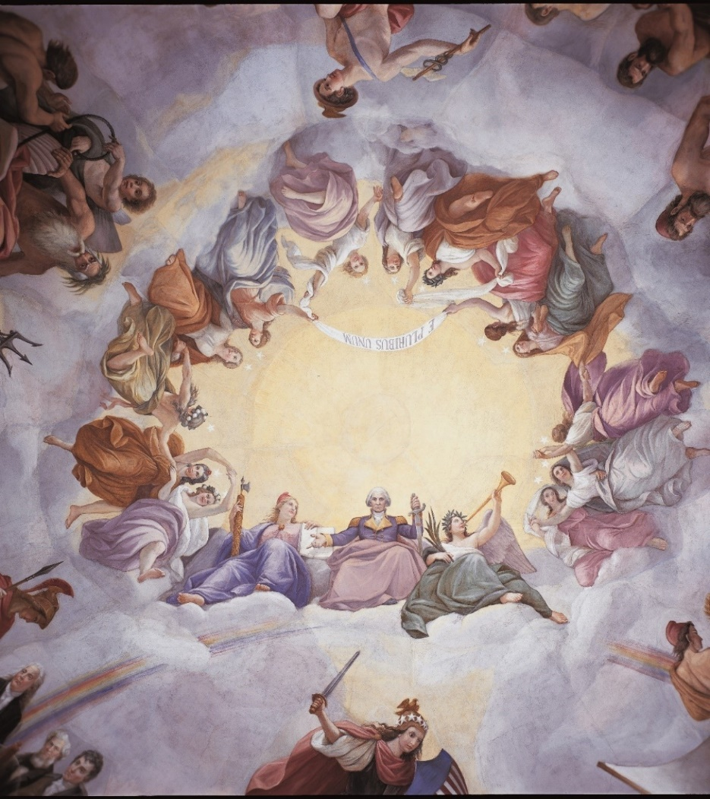

James was amazed.

"Without knowing it, you did the dress rehearsal for the Apotheosis of Washington!"

"Yeah, I hadn't thought of that, but I don't remember making the effort I did here. In Rome, maybe I took my time; it took me two years. At the Capitol, instead, I painted in less than a year a fresco larger twice as much."

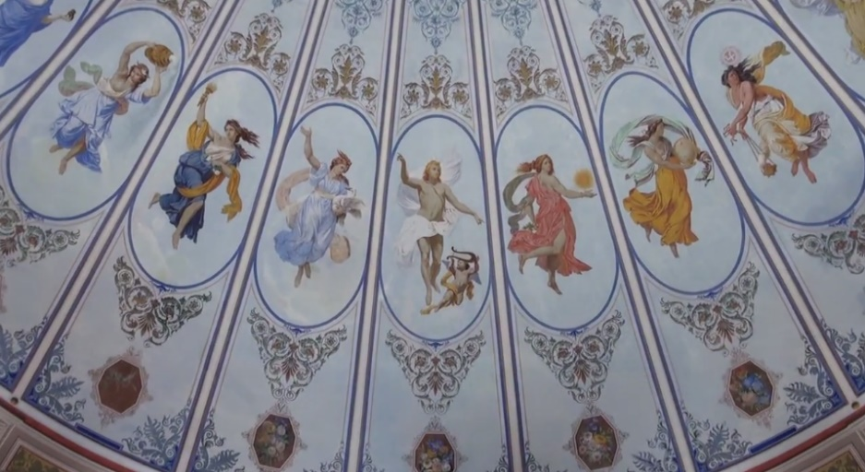

Detail of the Apollo and the Hours fresco. Villa Torlonia Theatre, Rome.

"Extraordinary, considering that you were thirty years older!"

"Roughly. I remember that the work in that theatre in Rome was fun, quiet and the patrons never pressed me. Among other things, I remember it was pleasant to paint false proscenium boxes with, inside, characters commenting, pointing, talking; some were curious, others laughing, others were not hiding their boredom. So, painting the various moods and attitudes of the audience amused me and created that cheerful and colorful atmosphere that Alessandro Torlonia wanted. I remember that for that 'fake' I brought in boys, models, and workers, asking them to be as natural as possible. We consumed rivers of wine and large quantities of porchetta. To finish, I painted the Fame and the coat of arms of the Torlonia family above the stage, as well as herms of illustrious men. During the work there were requests for variations on the theme, colors, and figures. I had many pleasant discussions and conversations with Donna Teresa, the Prince's wife. She often came to see me and, while I was working, gave me suggestions and ideas, which were, of course, orders. Finally, the work was completed to the satisfaction of the Torlonia family, but the theatre was never opened because Donna Teresa fell ill and died a few years later. Rumor had it that she had become insane, a situation in stark contrast to the happiness I was asked to create in my paintings. I must admit that Princess Theresa's illness saddened me not a little."

**BRÉ EDITIONS CONTACTS**

Facebook PROFILE https://www.facebook.com/bredizioni/

WEBSITE https://breedizioni.com

MAIL presidente@breedizioni.com prof. Silvia Ripà or Mr. Daniele Aiolfi, editorial manager

INSTAGRAM bre_editions